ANSIBLE – CHALLENGES
===========================================================================

Logged into your Jenkins EC2 server.
Installed Ansible:
yum install ansible -y
Installed Terraform:
yum install terraform -y
Verified Terraform:
terraform version
Purpose:
Prepares the Jenkins server to run Infrastructure (Terraform) and Configuration (Ansible) jobs.

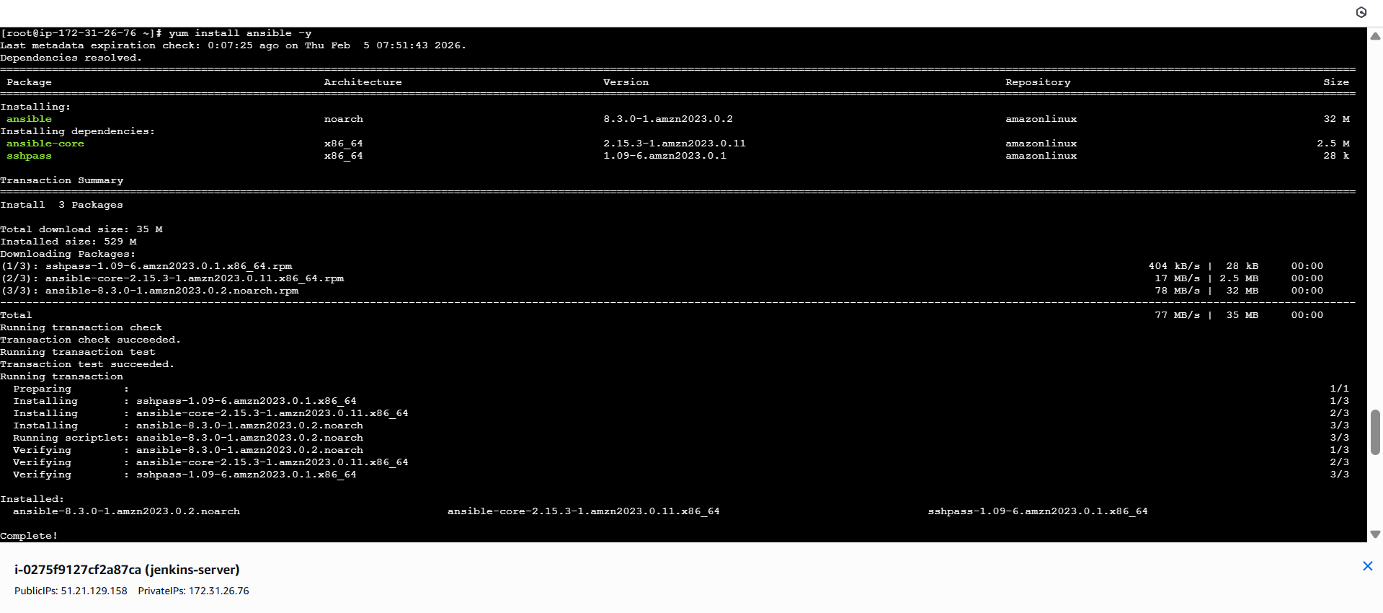

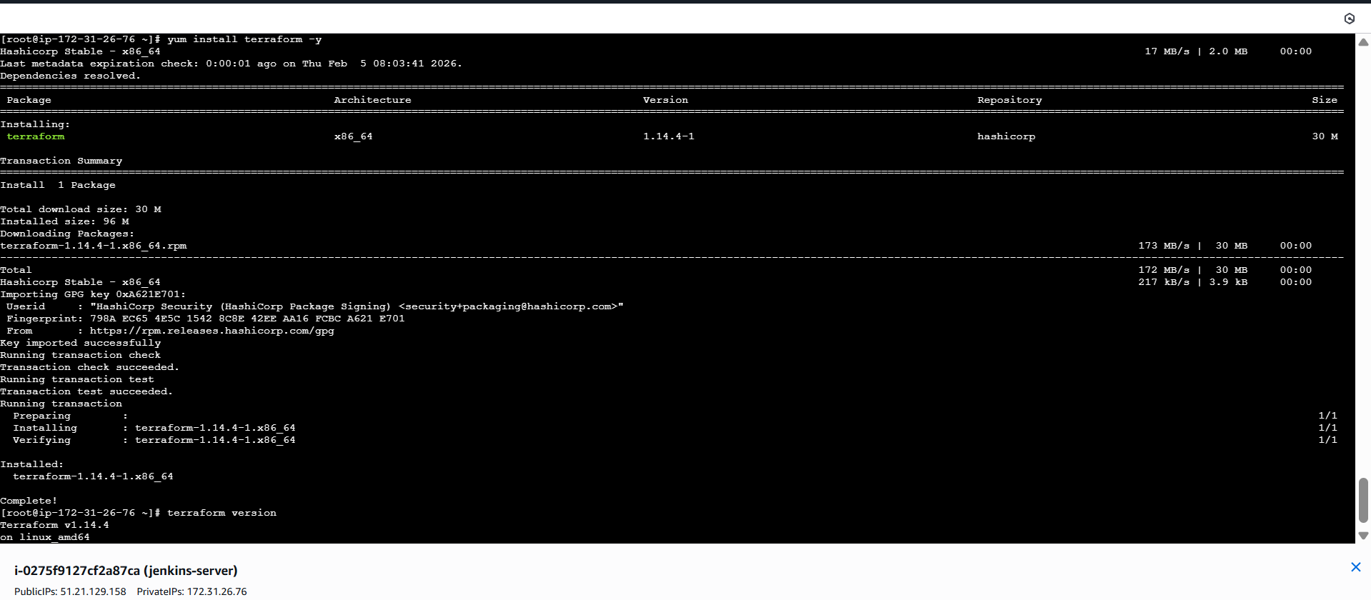
Opened Jenkins Dashboard
Went to:
Manage Jenkins → Plugins → Available Plugins
Searched: aws
Installed:
AWS Credentials Plugin
Purpose:
Allows Jenkins to authenticate and work with AWS services

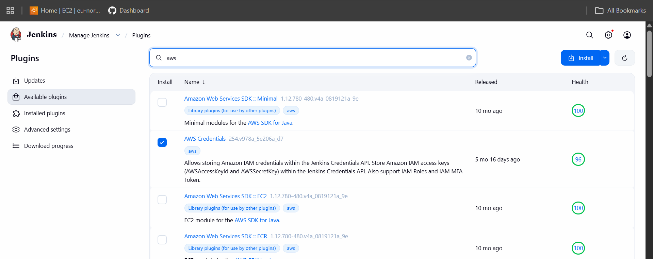
went to:
Manage Jenkins → Credentials → Global → Add Credentials
Selected:
Kind: AWS Credentials
Entered:
  - Access Key ID
  - Secret Access Key
- Saved as: aws-key

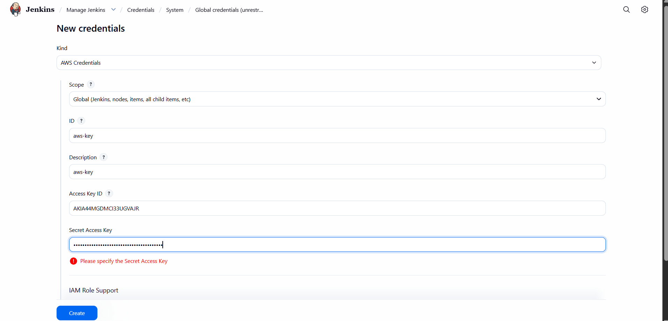
🔹 Add SSH Key (PEM File)
- Clicked Add Credentials
- Selected:
- Kind: Secret File
- Uploaded: linux.pem
- Saved as: ssh-key-file
Purpose:
Enables Jenkins to:
- Access AWS
- SSH into EC2 instances for Ansible

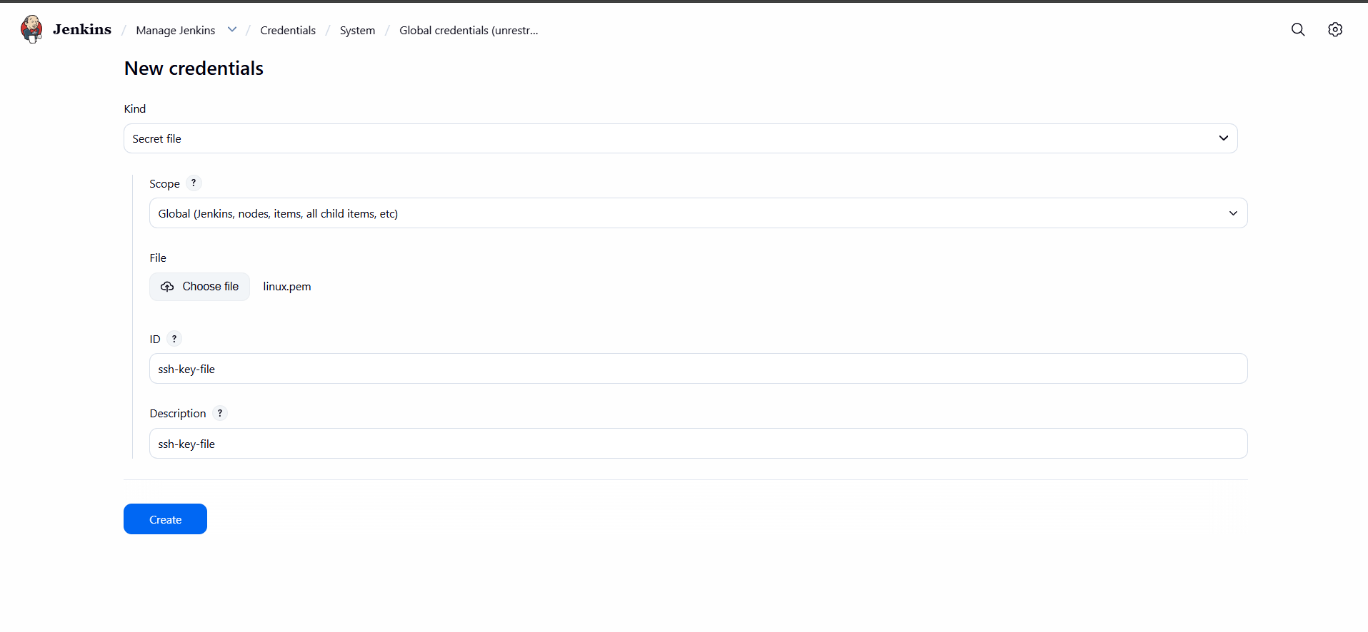

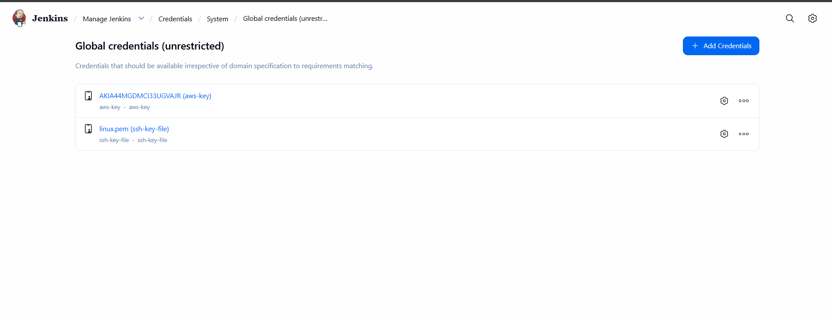
Created Jenkins Job: ansible-challenge
Opened Configure
Selected:
Definition: Pipeline script from SCM
SCM: Git
Added GitHub Repo:
https://github.com/mujahed1716/ansible-challange.git
Set Branch:
*/main
Script Path:
Jenkinsfile
Clicked Save
Purpose:
Jenkins now reads the pipeline automatically from GitHub.

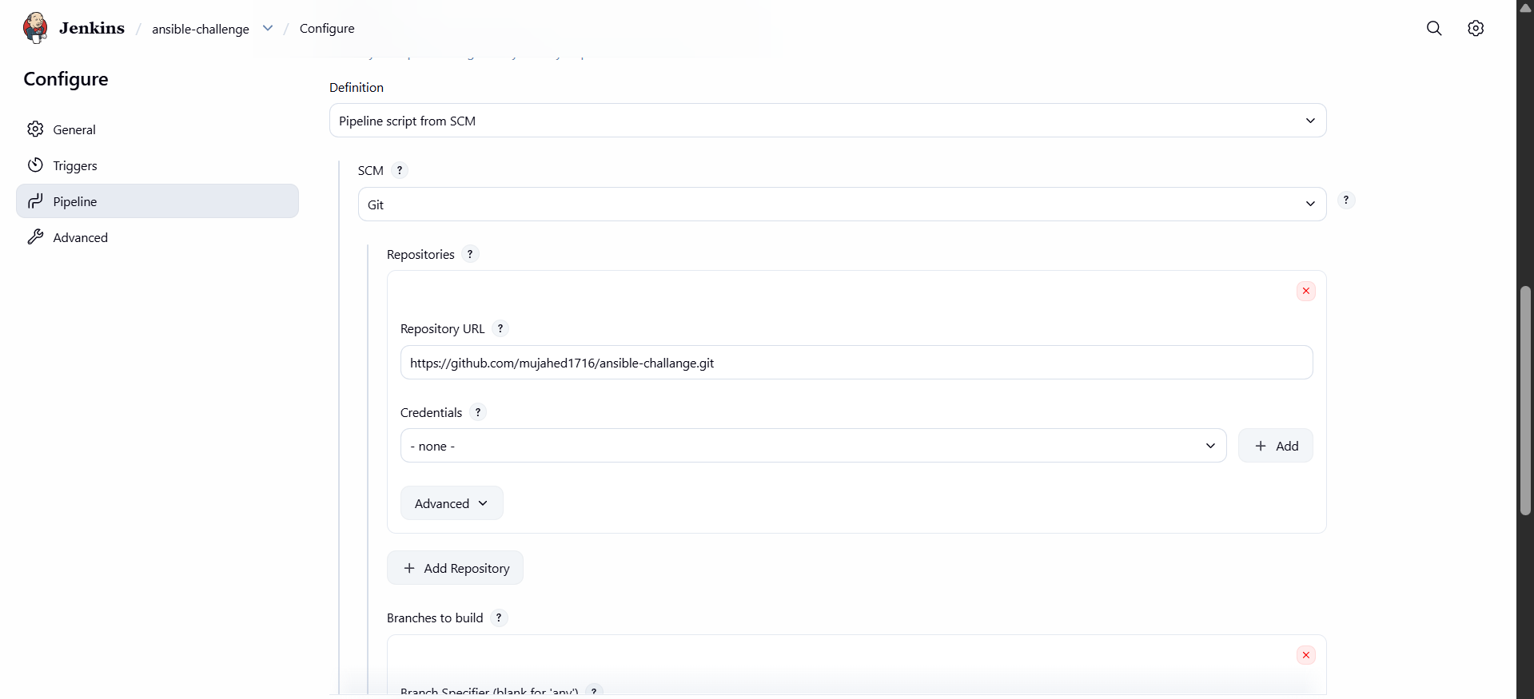

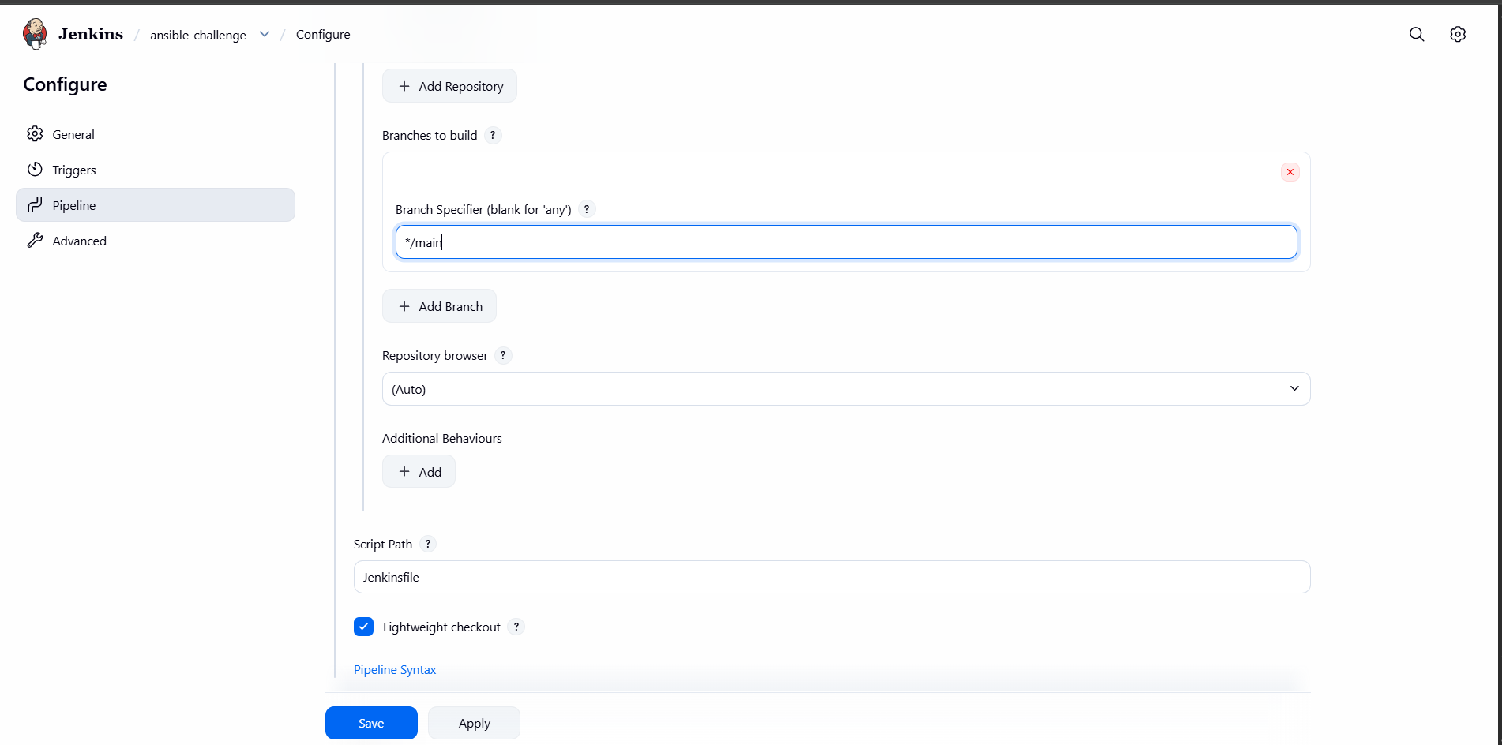

Opened Stage View
Observed pipeline stages:
  - Checkout SCM
  - Terraform Apply
  - Ansible Deploy
  - Post Actions
- Checked failed/success status
Purpose:
Shows live status of:
- Infrastructure creation
- Server configuration
- Deployment

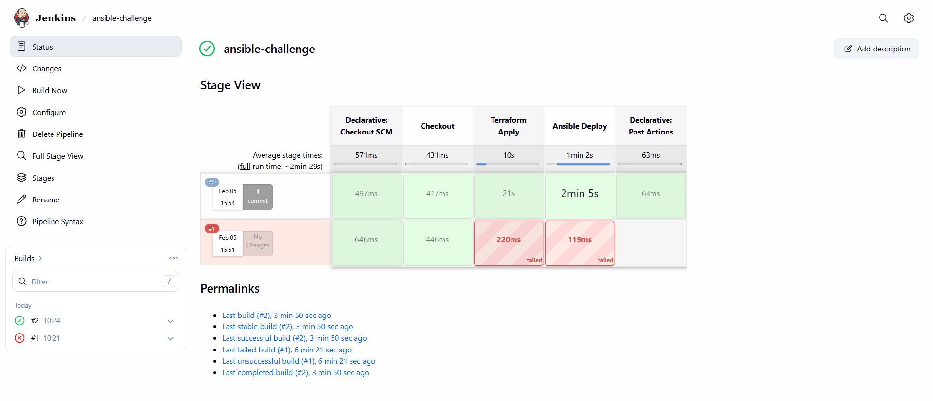

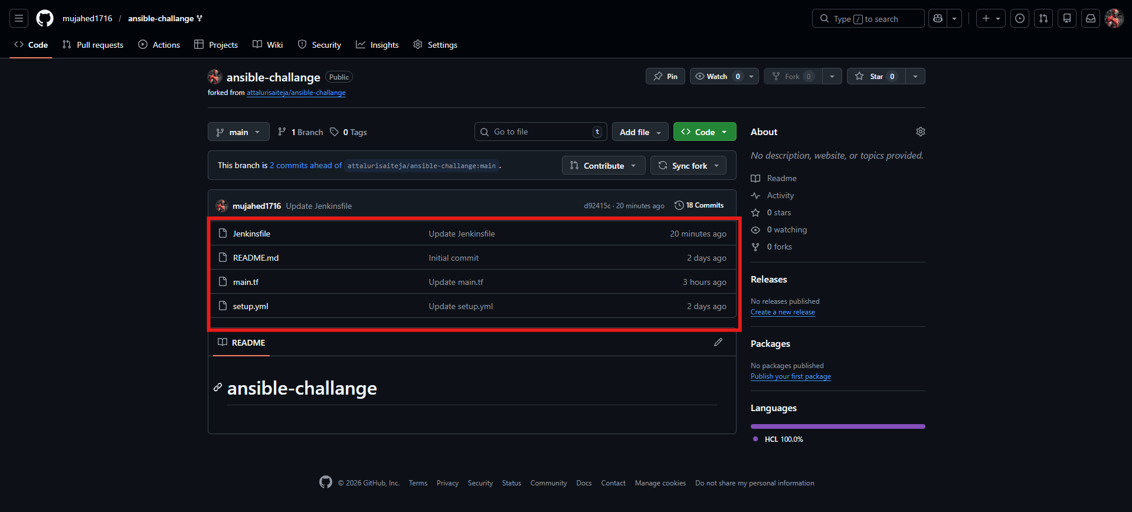

1. Open Security Group
↓
2. Allow Port 19999 (Netdata)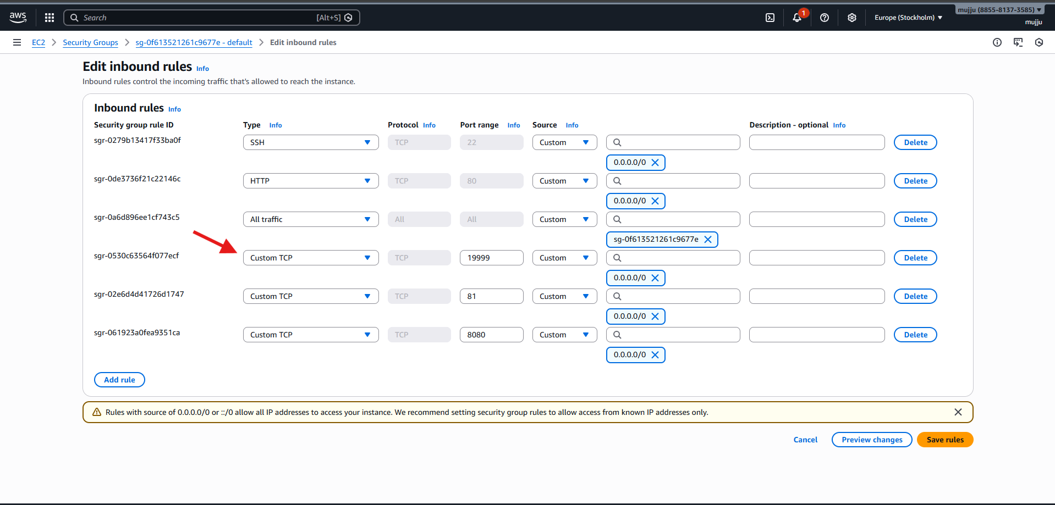
Two ec2s launched through code named c8 local which is for frontend
U21.local for backend
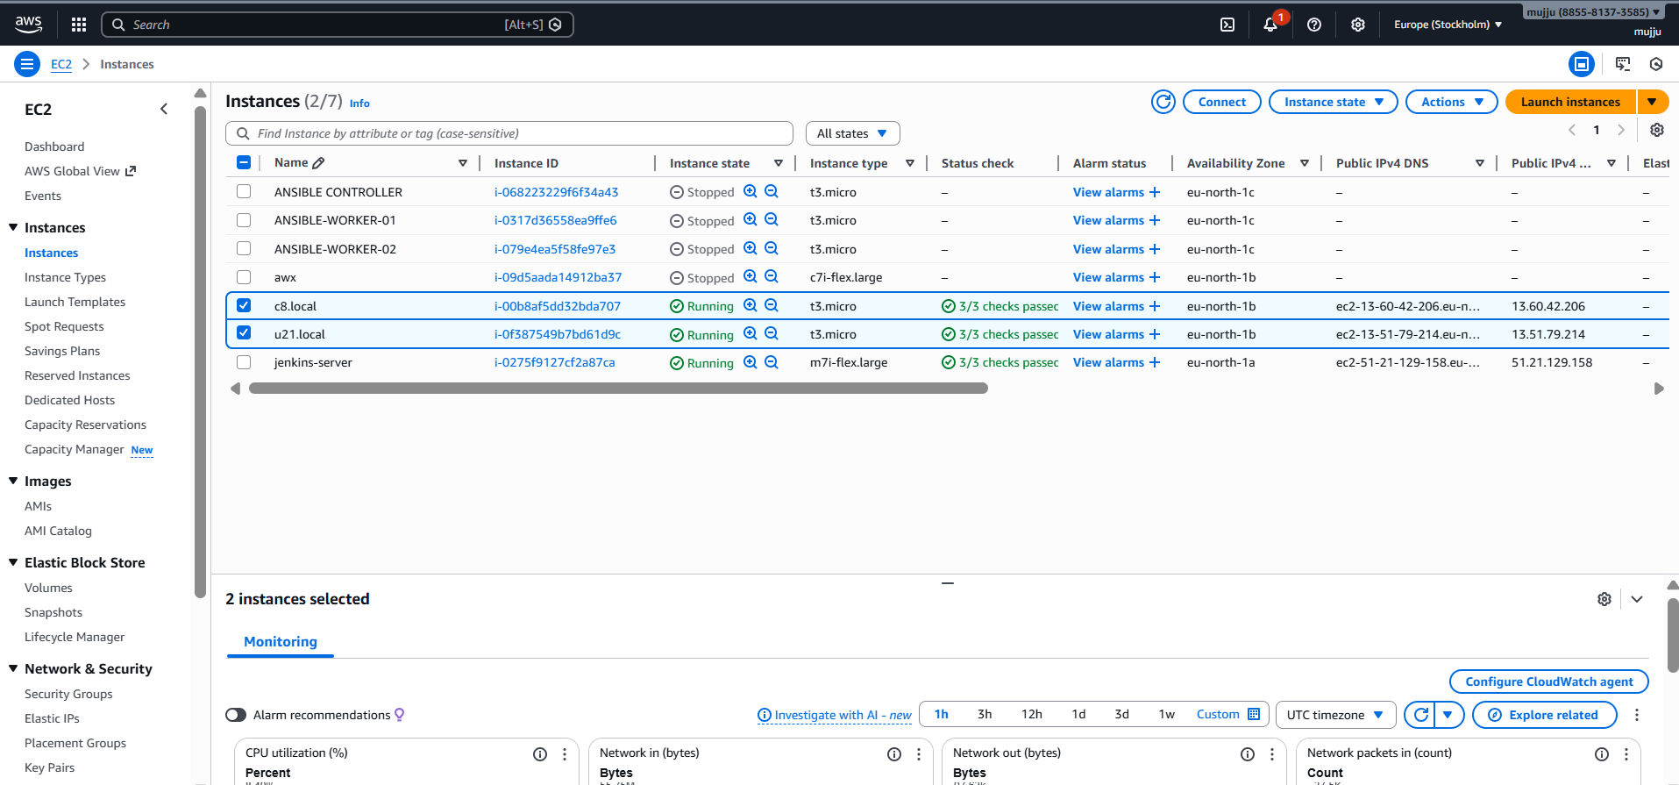

Copy Public IP of newly launched instances
↓
Open Browser → IP:19999
↓
Access Netdata Dashboard
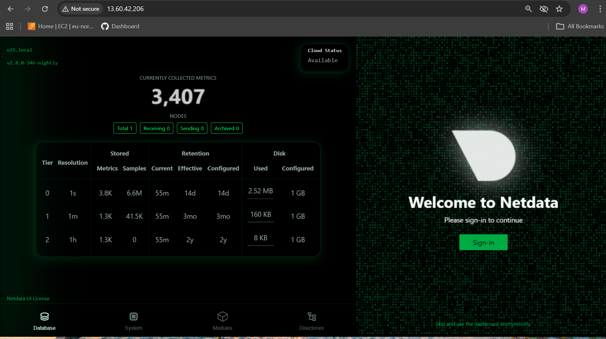

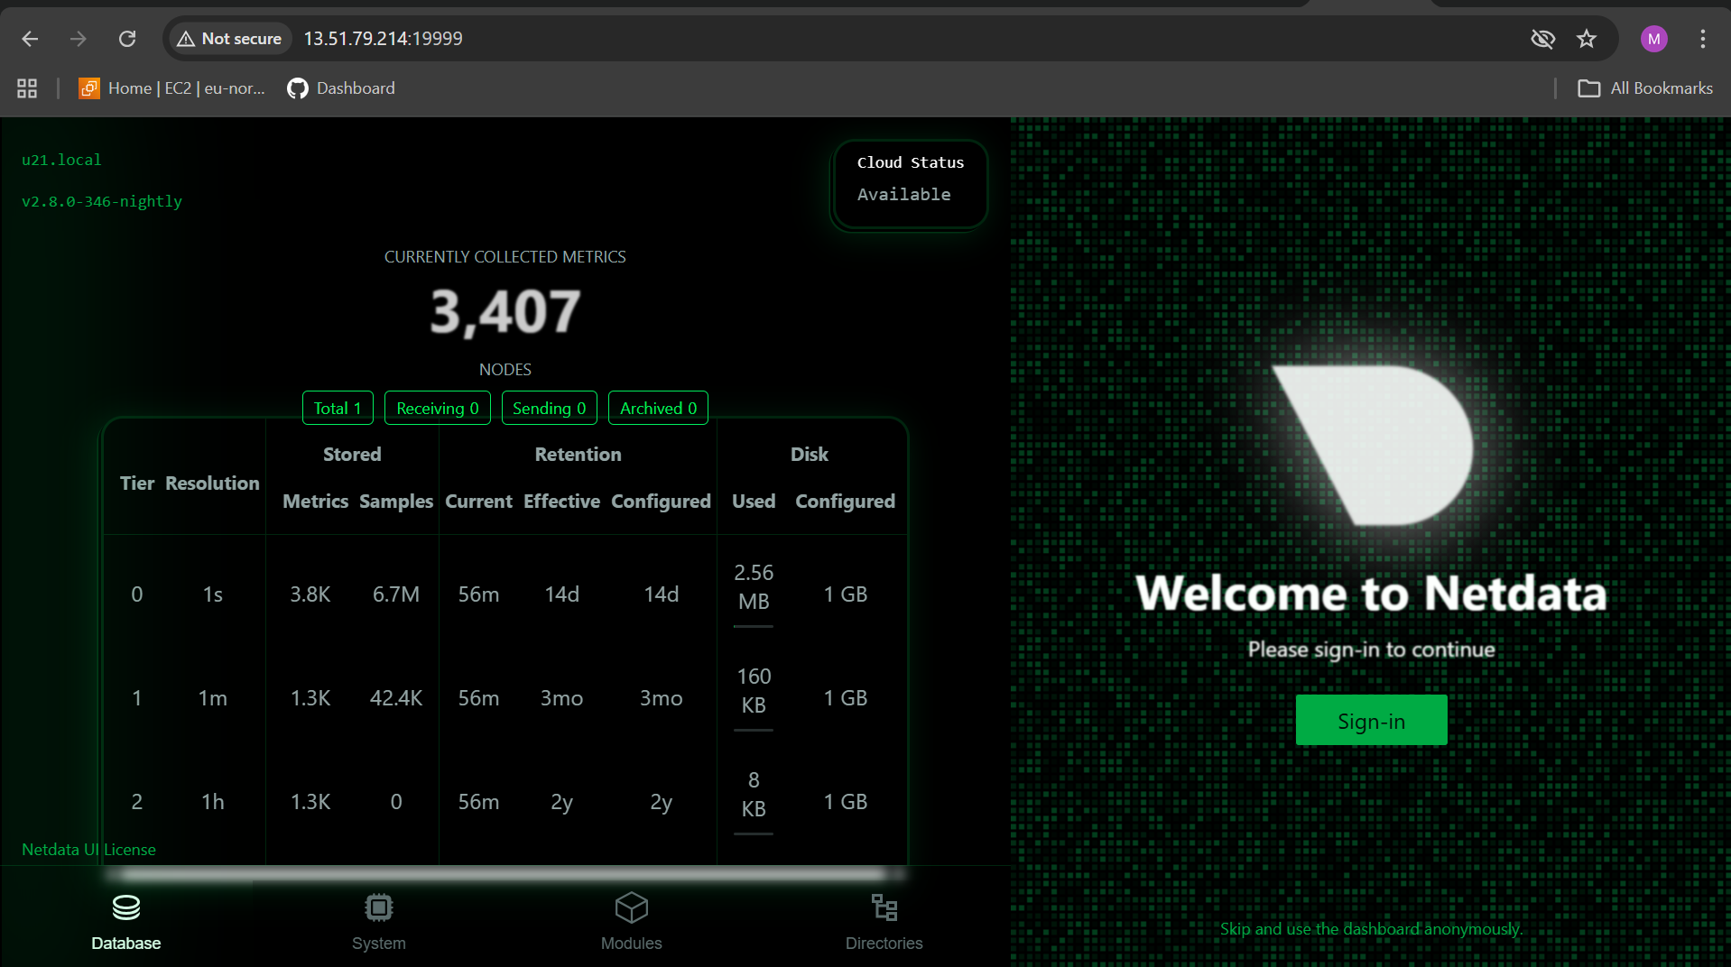

jenkins file :
============
pipeline {
agent any
environment {
// These IDs must match exactly what you created in Jenkins
AWS_ID = 'aws-key'
SSH_ID = 'ssh-key-file'
}
stages {
stage('Checkout') {
steps {
checkout scm
}
}
stage('Terraform Apply') {
steps {
withCredentials([aws(credentialsId: "${AWS_ID}", accessKeyVariable: 'AWS_ACCESS_KEY_ID', secretKeyVariable: 'AWS_SECRET_ACCESS_KEY')]) {
sh 'terraform init'
sh 'terraform apply -auto-approve'
}
}
}
stage('Ansible Deploy') {
steps {
echo "Waiting for instances to initialize..."
sleep 45
withCredentials([file(credentialsId: "${SSH_ID}", variable: 'SSH_KEY_PATH')]) {
sh "ansible-playbook -i inventory.ini setup.yml --private-key ${SSH_KEY_PATH} --ssh-common-args='-o StrictHostKeyChecking=no'"
}
}
}
}
post {
success {
echo "Deployment successful! Access the frontend IP on port 80."
}
}
}

main.tf file :
==========

provider "aws" {
region = "eu-north-1"
}
# First VM: Amazon Linux
resource "aws_instance" "amazon_linux_vm" {
ami = "ami-04233b5aecce09244" # Amazon Linux 2 AMI ID
instance_type = "t3.micro"
key_name = "linux"

tags = {
Name = "c8.local"
}

user_data = <<-EOF
#!/bin/bash
hostnamectl set-hostname c8.local
EOF
}

# Second VM: Ubuntu 21.04
resource "aws_instance" "ubuntu_vm" {
ami = "ami-073130f74f5ffb161" # Ubuntu 22.04 AMI ID
instance_type = "t3.micro"
key_name = "linux"

tags = {
Name = "u21.local"
}

user_data = <<-EOF
#!/bin/bash
hostnamectl set-hostname u21.local
EOF
}

output "frontend_ip" {
value = aws_instance.amazon_linux_vm.public_ip
}

output "backend_ip" {
value = aws_instance.ubuntu_vm.public_ip
}

resource "local_file" "ansible_inventory" {
filename = "inventory.ini"
content = <<-EOT
[frontend]
c8.local ansible_host=${aws_instance.amazon_linux_vm.public_ip} ansible_user=ec2-user

[backend]
u21.local ansible_host=${aws_instance.ubuntu_vm.public_ip} ansible_user=ubuntu
EOT
}

setup.yml file :
==============
---
- name: OS Hardening for Linux
hosts: all
become: yes
tasks:
- name: Disable SELinux (RedHat family only)
selinux:
state: disabled
when: ansible_os_family == "RedHat"
- name: Stop and disable firewall if present
service:
name: "{{ ansible_os_family == 'RedHat' | ternary('firewalld', 'ufw') }}"
state: stopped
enabled: no
ignore_errors: yes
# ---------------- BACKEND ----------------
- name: Configure Backend (Netdata)
hosts: backend
become: yes
tasks:
- name: Install Netdata (only if not installed)
shell: |
wget -O /tmp/kickstart.sh https://get.netdata.cloud/kickstart.sh
sh /tmp/kickstart.sh --non-interactive
args:
creates: /usr/sbin/netdata
- name: Ensure Netdata runs on port 19999
lineinfile:
path: /etc/netdata/netdata.conf
regexp: '^\\s*default port ='
line: ' default port = 19999'
notify: Restart Netdata
handlers:
- name: Restart Netdata
service:
name: netdata
state: restarted
# ---------------- FRONTEND ----------------
- name: Configure Frontend (Nginx Proxy)
hosts: frontend
become: yes
vars:
backend_ip: "{{ hostvars[groups['backend'][0]].ansible_host | default(groups['backend'][0]) }}"
tasks:
- name: Install Nginx
package:
name: nginx
state: present
- name: Reset nginx conf.d directory
file:
path: /etc/nginx/conf.d
state: directory
mode: '0755'
- name: Write clean nginx.conf
copy:
dest: /etc/nginx/nginx.conf
mode: '0644'
content: |
user nginx;
worker_processes auto;
error_log /var/log/nginx/error.log warn;
pid /run/nginx.pid;
events {
worker_connections 1024;
}
http {
include /etc/nginx/mime.types;
default_type application/octet-stream;
log_format main '$remote_addr - $remote_user [$time_local] "$request" '
'$status $body_bytes_sent "$http_referer" '
'"$http_user_agent" "$http_x_forwarded_for"';
access_log /var/log/nginx/access.log main;
sendfile on;
keepalive_timeout 65;
include /etc/nginx/conf.d/*.conf;
}
- name: Write proxy configuration
copy:
dest: /etc/nginx/conf.d/proxy.conf
mode: '0644'
content: |
server {
listen 80 default_server;
server_name _;
location / {
proxy_pass http://{{ backend_ip }}:19999;
proxy_http_version 1.1;
proxy_set_header Host $host;
proxy_set_header X-Real-IP $remote_addr;
proxy_set_header X-Forwarded-For $proxy_add_x_forwarded_for;
proxy_set_header X-Forwarded-Proto $scheme;
}
}
- name: Validate nginx configuration
command: nginx -t
register: nginx_test
changed_when: false
- name: Show nginx validation output
debug:
var: nginx_test.stderr
- name: Start and enable nginx
service:
name: nginx
state: restarted
enabled: yes

